Cardiac Arrest Detector (Group 5)

Kyle Hanks 

*Electrical and Computer Engineering Department*

*George Mason University*

Fairfax, Virginia, 22030

[khanks@gmu.edu](mailto:khanks@gmu.edu)

Kyle Loyd Guthrie 

*Electrical and Computer Engineering Department*

*George Mason University*

Fairfax, Virginia, 22030

[kguthri@gmu.edu](mailto:kguthri@gmu.edu)

Shamili Mownika Tetali

*Electrical and Computer Engineering Department*

*George Mason University*

Fairfax, Virginia, 22030

[stetali@gmu.edu](mailto:stetali@gmu.edu)

Sunanda Roy

*Electrical and Computer Engineering Department*

*George Mason University*

Fairfax, Virginia, 22030

[sroy9@gmu.edu](mailto:sroy9@gmu.edu)

*Abstract*— Internet of Things is considered one of rapidly advancing innovative technologies that has influenced several areas, modelling a shift in traditional healthcare systems. Proliferation of IoT devices has enabled several opportunities to improve quality of life and providing methods to reduce mortality rates. Healthcare Domain is one important area requiring high standards of accuracy and precision in determining key metrics. The objective of this project is to design a Proof-of-concept prototype based on research with Connected Healthcare multisensory IoT system that extracts human body vital parameters and derive an early alarm of fatal cardiac arrest. The design goal primarily focuses interfacing various sensors and implementing data collection software methodologies by means of considering cost-effective techniques to potentially bring the technology closer to users and aid larger human population.

Keywords—IoT, Arduino, Bluetooth, pulse, temperature, Android, Firebase

1. INTRODUCTION

Advancements in various fields of modern Computing and Communication technology has embraced new ideas in IoT design implementations. These innovations provided extensive opportunities to improving how traditional systems operated for betterment of developing enhanced lifesaving solutions. The importance of Healthcare and especially Cardiac monitoring systems has come a long way with extensive research put into characterizing cardiac abnormalities and human organ functions and tremendous studies have proved that timely monitoring of various vital parameters will have a lifesaving outcome. With the evolution of IoT it was possible to bring in these technologies together and implement medical solutions for proactive detection of health issues.

The high-level design idea on this project is to develop an embedded system using Arduino Nano and interface it to various sensors like pulse and temperature which are basic parameters to detect anomalies in cardiac function. Essentially, the design aspect would leverage built-in low power Bluetooth communication methods to integrate sensor data into an Android based application which would then establish a secure channel to a cloud based solution for data acquisition and analysis.

1. USE CASE DESCRIPTION

Fig. 1. Block diagram of key components

The use case in Figure 1 above serves as a framework for how we should approach designing our system. In general, use cases in IoT devices provide developers with clear goals for what the IoT device should be capable of. Without this, it is hard to execute a clear vision for the design of an IoT system. Our use case displays our two main devices, the Arduino Nano 33 IoT and the Android Application, and shows how they interact with the user and with a cloud storage database.

As pictured, the Arduino takes sensor readings from the user and transmits them via Bluetooth to the Android application, which then processes cloud storage and user display. The Arduino’s sensor integration process is where one of our main challenges related to the use case occurred. We attempted to use two different temperature sensors when implementing this design, however as stated in a later section, the sensor’s readings were a bit inaccurate in that they had trouble sensing specifically body heat over the ambient temperature of the room. Between this issue and the need for an accurate pulse sensor, we were able to use the use case to inform our decision in determining which components to select and how to approach our solution.

1. RELATED WORKS

Over the past few years, several related IoT devices have offered solution to monitor, report, and display data relevant to preventing or predicting heart troubles in a user. In 2019, a wearable device was suggested that uses embedded ECG and temperature sensors to monitor the condition of the wearer’s heart. [1] This data is then sent via Bluetooth to a smartphone to classify whether the wearer has any present abnormalities in the condition of their heart. The Android platform performs a quantitative heart rate analysis and displays the real-time plots of the ECG signal and body temperature. The app can trigger a warning if the ECG signal or body temperature reaches above a critical threshold. The app also has functionality for creating an account with useful patient data that can be expanded to include the ability for healthcare workers to remotely view the data collected by the app. This design served as a basis for our implementation. It has some similar aspects and functionalities but uses slightly different techniques. Over time, our implementation could be expanded to be more cost and energy efficient utilizing a different Arduino board and sensors than the one proposed in this paper.

In 2018, another wearable IoT device to detect cardiac issues was proposed by Ashwini K and Komala K. [2] The main goal of this implementation is to increase the accuracy of the ECG readings by increasing the number of sensors worn. This device uses the AD8232, a three-lead ECG sensor that allows for an ultralow power analog-to-digital converter or an embedded microcontroller to acquire the output signal easily. The proposed model would also be able to give a voice output alerting the wearer to potential cardiac issues while simultaneously sending this data to a caretaker along with the location of the user if a serious issue occurs. The main shortcoming of this implementation is that the AD8232 sensor is not suited for constant wearing/monitoring throughout everyday situations. If a developer wanted to expand on the goal of making ECG readings more reliable using multiple sensors, they could start by improving placement and selection of the wearable sensors in the monitoring system. This approach could also be used to improve the reliability of our own device in future work.

1. IOT TECHNICAL SOLUTION

We propose building a hardware prototype along the lines of the experimental setup described in [1]. The goal of this prototype IoT device is to capture the instantaneous heart rate and body temperature readings of a human and perform computations which would result in the detection of an imminent danger of cardiac arrest in that person.

1. *System Architecture*

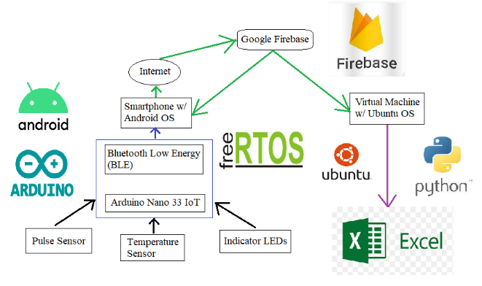

Fig. 2. Data flow diagram of entire solution

We split the entire architecture of the solution into five essential components:

1. *Sense*
2. *Compute*
3. *Transmit*
4. *Store*
5. *Retrieve*

The above components are described below in greater detail.

1. *Sense*

The following sensors have been used to capture user data:

1. *Tragoods pulse sensor/heart rate monitor*

ARDUINO LIBRARY: PulseSensor Playground

This module [2] can be used to detect our heart rate by clipping it to sensitive areas like an earlobe or fingertip. In our setup, we connect it to a fingertip. The captured signal is a raw voltage which can be plotted on any serial plotter to show the heart rate varying over time.

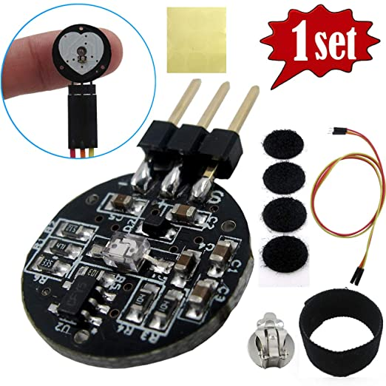

Fig. 3. Components of pulse sensor package

The front side of the sensor (with the heart logo) makes the contact with the skin. This front side has a small round hole, which is where the LED (reverse mounted at the back side) shines through from the back. Just below this round hole is a little square, which is an ambient light sensor.

The LED shines light into the fingertip or earlobe, or other capillary tissue, and sensor reads the light that bounces back.

1. *FTCBLock TMP36 temperature sensor*

ARDUINO LIBRARY: TMP36

This module [3] is a low voltage and high precision temperature sensor, which is a possible candidate for reading body temperatures.

CHALLENGE: This sensor does not give stable and accurate values obfuscating our future calculations.

Fig. 4. TMP36 temperature sensor

1. *Compute*

For detecting a heartbeat, we set a threshold value and classify any reading above that as a heartbeat and below as none.

CHALLENGES: Obtaining readings in the expected range required setting the correct threshold value and sampling interval, so the correct number of heartbeats are detected per unit time interval. We solved this problem by observing the signal waveform to detect threshold and surveyed online implementations for setting the sampling interval. As a part of this verification, we added support for computing the Beats Per Minute (BPM) periodically during a user session. Our obtained BPM values were in the expected normal range (~60).

The temperature readings can be obtained using the associated library functions or manually calculated (ensure Arduino Nano 33 IoT operating voltage is factored into calculations).

1. *Transmit*

The computed sensor data are transmitted to the receiver device (a smartphone) using the built-in Bluetooth Low Energy (BLE) module on Arduino Nano 33 IoT device.

1. *Store*

The smartphone device (running Android OS) stores these sensor readings in real-time into a cloud database (Firebase).

1. *Retrieve*

The data stored in the cloud database is queried back by our Android app with the future goal of plotting them into a user-friendly waveform for the convenience of the end user.

1. IMPLEMENTING BLE COMMUNICATION AND FIREBASE STORAGE
2. *Overview of BLE*

BLE is a wireless personal area network technology which provides a low power and low-cost interface for data transmission. Using BLE, data can be transmitted up to a range of 100 m and Android apps can communicate to edge devices having stricter power requirements such as proximity sensors, heart rate monitors, and fitness devices.

1. *Overview of Firebase storage*

Firebase is a cloud platform developed by Google for developing mobile and web applications. It provides end-users a means to store their data on a cloud server in real-time and perform different analytics on user data. Firebase provides numerous platforms for supporting a wide range of user requirements like performing user authentication, storing data into a real-time database, setting up a cloud server, executing cloud functions and implementing machine learning applications.

1. *Implementing BLE*

In this project, BLE has been used to transmit sensor data from an Arduino Nano 33 IoT acting as the peripheral device (client) to a Samsung Galaxy M11 smartphone acting as the central device (server). Arduino’s FreeRTOS libraries have been used to implement multithreaded reading of sensor values.

1. *CLIENT side*

Sensor readings from pulse sensor and temperature sensor are captured continuously and sent in parallel over two respective threads to the server end. These 2 sensor readings aretransmitted as Arduino BLE objects of type *BLEIntCharacteristic* to the Android app listening on server side.

1. *SERVER side*

The server side comprises of an Android app developed in-house using Android Studio software on Windows 10 platform. This app captures the exported Arduino BLE characteristic readings and converts them to Android objects of type *BluetoothGattCharacteristic* for subsequent processing.

1. *Implementing Firebase storage*

In this project, the Cloud Firestore database (server) provided by Firebase has been used to receive real-time data from an Android app running on a smartphone (client). This stored data is also read back by the Android app for possible future applications.

1. *CLIENT side*

Due to the asynchronous nature of the Android API (which reads the incoming sensor data over multiple threads), the data are stored to Cloud Firestore storage asynchronously as well.

1. *SERVER side*

For each continuous execution of the experimental setup, all the incoming data from Android data are stored as a single collection of multiple documents. Here, each document represents an individual sensor reading.

1. *Benefits of this communication interface*

The BLE communication protocol allows for the transmission of sensor data from client to server with extremely low latency, which may not be possible if implemented using other communication protocols like Wi-Fi, Bluetooth (BLE’s ancestor), etc. In addition, the low power consumption of BLE meets the requirement of a robust IoT device driven by power supplies of low range.

1. *Algorithm*
2. *Edge device (Arduino Nano 33 IoT)*

**Input:** Sensor readings: pulse (p_raw) and temperature (t_raw).

**Output:** BLE characteristic objects of sensor readings: p_char and t_char.

**Procedure:**

1. Initialize a BLE service object (srv).
2. Initialize BLE characteristic objects (p_char and t_char).
3. Add p_char and t_char to srv and advertise srv.
4. Create separate RTOS threads for reading respective sensor values (p_thread and t_thread).
5. Optionally create RTOS thread for monitoring tasks usage.
6. Schedule all RTOS tasks for continuous reading of sensor values at fixed intervals.
7. *Gateway device (Smartphone with Android OS)*

**Input:** Number of samples (set of pulse and temperature readings) to be captured from peripheral device (Arduino) - N.

**Output:** Cloud Firestore collection (user session) of multiple documents (sensor readings).

**Procedure:**

1. Establish connection to the peripheral device.
2. Initialize a counter for tracking the number of samples read.
3. Convert each (Arduino) BLE characteristic object to a (Android) BluetoothGatt characteristic object.
4. Establish connection to the Firebase instance.
5. On successful completion of a read characteristic function, convert to read data to desired format and store it into the cloud database.
6. Final collection consists of N sensor values.
7. RESULTS
8. *List of deliverables*
9. Arduino code and serial log
10. Android app and logcat log
11. Demo video
12. Fritzing diagram
13. Google Firebase to MS Excel conversion
    1. Python script to extract data from the cloud and plot them into a graph.
    2. Google cloud authentication key (JSON file).
    3. Input text file (contains names of collections to be plotted).
    4. Example output graphs for N = 5 and 100.
    5. Associated LINUX commands
14. *Selected outputs*

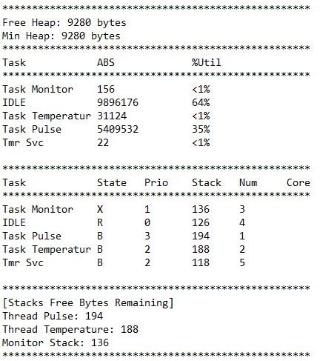

Fig. 5. Example of RTOS task usage

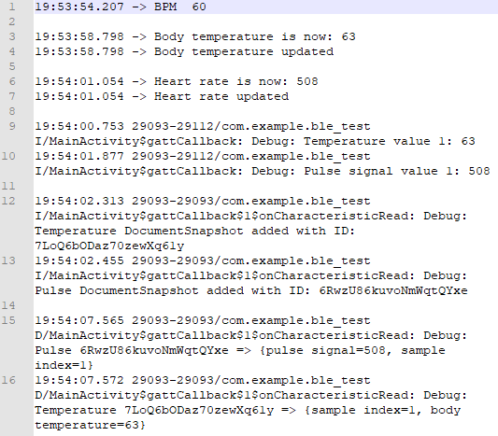

Fig. 6. Data flow of a sample sensor reading

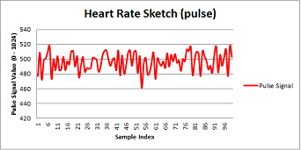

Fig. 7. Pulse signal variation (N = 100)

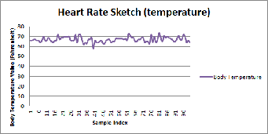

Fig. 8. Body temperature variation (N = 100)

1. *Future scope*

The accuracy of sensor readings can be improved with further market survey of IoT devices, although the base IoT device of Arduino Nano 33 IoT will always be preferred over its higher footprint counterparts.

Advanced data analytics using state-of-the-art machine learning techniques can be performed on the output waveforms, to detect abnormalities in the human body’s vital parameters.

1. CONCLUSION

As healthcare needs are increasingly concerning and monitoring human body vitals becomes an important paradigm, we attempted to demonstrate the IoT capabilities in the ehealth domain. This experiment primarily focused on design and development of an integrated smart IoT system to predict and monitor health abnormality in a user. We managed to create a low power communication channel between smart IoT device and smartphone application and were successfully able to connect to Google Firebase to store the values to derive the value prospects of this study.

1. DISCUSSION
2. *RTOS task usage*

The sample output in Fig. 5 shows that the major chunk of non-idle execution time of the microcontroller is consumed by the pulse sensor reading task (35%). While temperature sensor reading task consumes negligible share of the microcontroller’s execution time. This observation directly correlates to the assigned priorities of these sensor reading tasks, pulse reading task having higher priority than temperature reading task. On the contrary, we find that the monitor task consumes the most amount of stack space followed by the temperature reading task. The least amount of stack space is occupied by the pulse reading task, indicating an efficient software implementation of their driver library.

1. *Data flow of sensor readings*

Fig. 6 shows the typical flow of information from the edge device to the cloud storage via the gateway device. This output shows one of the two implemented ways of retrieving stored data from Firebase. Each entry in the log is taken from either the serial output of Arduino IDE or logcat output of Android Studio IDE while the desired number of sensor readings are being captured. The individual entries are arranged in increasing order of their timestamps to signify the continuity of data flow from one node to another node in the system architecture.

NOTE: To avoid transmission of redundant data, the sensor readings are transmitted via BLE from Arduino device to Android device only if there is a change in read value. This is expected to optimize the power consumption of the resource constrained Arduino Nano 33 IoT device.

Line 1 shows the current value of BPM. Lines 3 and 4 show an updated temperature reading. While lines 6 and 7 show an updated pulse reading. Lines 9 and 10 show the values received by the Android App. Lines 12 and 13 show these values being written to Firebase. While lines 15 and 16 show these vales being retrieved from Firebase.

1. *Pulse signal and body temperature variation*

The waveforms shown in Fig. 7 and Fig. 8, show the pulse signal and body temperature varying within a stable range of low and high values, indicating a healthy human heart rate and body temperature.

REFERENCES

1. AKM Jahangir Alam Majumder, Yosuf Amr ElSaadany, Roger Young, Donald R. Ucci, "An Energy Efficient Wearable Smart IoT System to Predict Cardiac Arrest", Advances in Human-Computer Interaction, vol. 2019.
2. Ashwini K, Komala K, “Wearable Heart Attack Detector using IoT”, International Journal of Engineering Research & Technology. 2018.
3. Pulse Sensor Playground. [<https://github.com/WorldFamousElectronics/PulseSensorPlayground>]
4. TMP36 Temperature Sensor. [<https://learn.adafruit.com/tmp36-temperature-sensor>]
5. The Ultimate Guide to Android Bluetooth Low Energy. [<https://punchthrough.com/android-bleguide/>]
6. Android Developer Guides. [<https://developer.android.com/guide>]
7. Add Firebase to your Android project. [<https://firebase.google.com/docs/android/setup>]
8. Cloud Firestore. [<https://firebase.google.com/docs/firestore>]
9. Things You Should Know About Bluetooth Range. [<https://blog.nordicsemi.com/getconnected/things-you-should-know-about-bluetooth-range>]
10. Python Client for Google Cloud Firestore. [<https://googleapis.dev/python/firestore/latest/index.html>]
11. ArduinoBLE library. [<https://www.arduino.cc/en/Reference/ArduinoBLE>]
12. Introduction to Bluetooth Low Energy. [<https://learn.adafruit.com/introduction-to-bluetooth-low-energy/gatt>]

APPENDIX

1. *Technical terms definition (Arduino)*

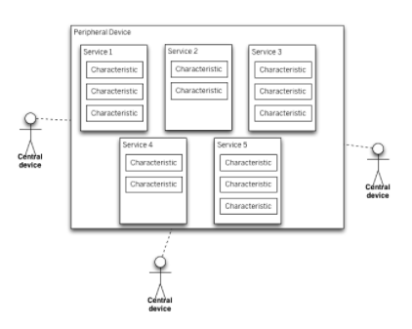

Fig. 9. Layout of BLE entities on Arduino devices

1. BLECharacteristic

This class is used to represent information which are updated when there is a significant change to them.

1. BLEDevice

This class is used to get information about the devices connected or discovered while scanning the BLE interface.

1. BLEService

This class represents a collection of information entities which are exposed from a specific BLE device. A BLE service can have one or more characteristics, and each service distinguishes itself from other services by means of a unique numeric ID called a UUID, which can be either 16-bit (for officially adopted BLE Services) or 128-bit (for custom services).

1. Central

This type of devices acts as clients in the BLE world to read information available from peripherals.

1. Handle

This acts as a pointer to the new task created using FreeRTOS API, which can then be used to perform other operations including deletion of the respective task.

1. Heap

The heap is an area of dynamically allocated memory that is managed automatically by the FreeRTOS APIs.

1. Peripheral

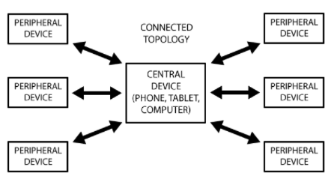

Fig. 10. BLE devices in a connected environment

This type of devices acts as servers in the BLE world, posting data to the central device to read from or write to. A peripheral can only be connected to one central device (such as a mobile phone) at a time, but the central device can be connected to multiple peripherals.

1. Priority

This numeric value indicates the preference with which microcontroller time is allotted to the scheduled tasks. Low priority numbers denote low priority tasks. The idle task has priority zero.

1. Stack

Stacks are regions of memory where data is added or removed in a last-in-first-out (LIFO) manner.

1. Thread

A thread of execution is the smallest sequence of programmed instructions that can be managed independently by a scheduler, which is typically a part of the operating system.

1. *Technical terms definition (Android)*

|  |
| --- |
| 1. BluetoothGatt   This class provides Bluetooth GATT functionality to enable communication with BLE devices.  GATT is an acronym for the Generic Attribute Profile, and it defines the way that two BLE devices transfer data back and forth using concepts called Services and Characteristics. It makes use of a generic data protocol called the Attribute Protocol (ATT), which is used to store Services, Characteristics and related data in a simple lookup table using 16-bit IDs for each entry in the table. |
| 1. BluetoothGattCallback   This abstract class is used to implement BluetoothGatt callbacks.  A callback is any executable code that is passed as an argument to other code; that other code is expected to call back (execute) the argument at a given time. This execution may be immediate as in a synchronous callback, or it might happen at a later point in time as in an asynchronous callback. |
| 1. BluetoothGattCharacteristic   A GATT characteristic is a basic data element used to construct a GATT service. The characteristic contains a value as well as additional information and optional GATT descriptors. |
| 1. BluetoothGattService   This class represents a Bluetooth GATT Service which contains a collection of GATT characteristics, as well as referenced services. |

1. *Technical terms definition (Firestore)*

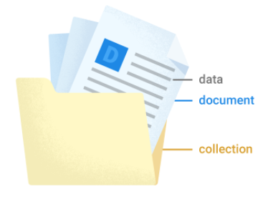

Fig. 11. Representation of Firestore entities

1. Collection

It is a container for documents.

1. Document

A document is a lightweight record that contains fields, which map to values. It is the unit of storage in Cloud Firestore.